Professional courses in Spa and massage

Spa : Body Treatment 120 hrs. (Only at Salaya)
Class schedule
1) Oil Massage 6 days
2) Scrub Sauna Mask and Waxing 5 days
3) Anti - Cellulite Massage 4 days
Class Time : From 9 AM to 4 PM
Location: Chetawan health school in Salaya.
Fee : 25,000 Baht (include books)
Class schedule on every 2 month on the 2nd Monday of January, March, May , July, Septemeber, and November for 20 days except Sunday. Class will be completed on Tuesday of the 4th week
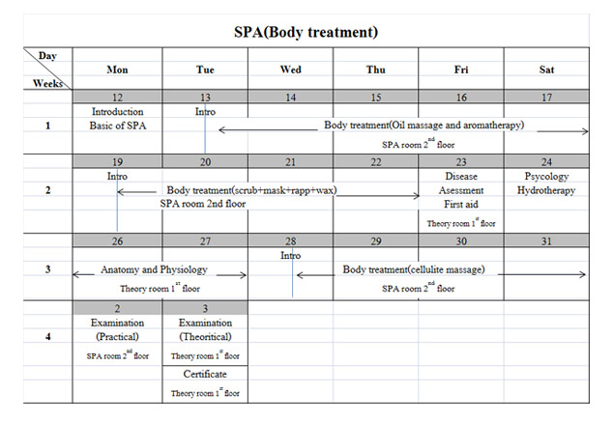

Professional Thai Massage for Health 165 hrs.
This Professional Thai massage for Health for 165 hours which is comprises of 100 hours of practical session and 65 hours for theoretical session and examination. (with anatomy and physiology for 24 hours, Thai traditional medicine, pharmacy and massage for 36 hours) You willlearn how to perform Thai Massage for Health on the whole body, herbal massage vs. herbal sauna and head, backand shoulder massage in the sitting position properly. You will beable to determine what kind of massage that the patient need for the whole session.and Ascetic self-stretching. It takes about 26 days to complete. This course will offer each month start on the first day of the month except Sunday.
*Students in this course are required to stay at the school’s hostel.
Apply Before the class until the1st of the month.
Class Time: From9 AM to 5 PM for 26 Days Monday - Saturday.
Fee : 30,000 Baht (include books)
Location : Chetawan Health school in Salaya branch only

Professional Thai Massage Therapy I (200 hours)
The 5 week course is presently offered to everybody interested in seriously studying the art of Thai therapeutic massage. The 200 hour course comprises 32 hours theoretical study about health science and traditional medicine, 82 hours Thai therapeutic massage and advanced Thai ascetic self stretching, and 86 hours professional training.
After experiencing the art of traditional Thai massage in the “professional Thai massage for health” course, this sophisticated course provides serious training to show the students the original aspiration and full potential of Thai massage. Massage as a traditional Thai medical practice is able to cure diseases and restore health. The students will study the required methods and techniques to treat at least 25 ailments; e.g. frozen shoulder, carpal tunnel syndrome, stiff neck, ankle and wrist sprain, etc.
Course schedule:
The 5 week course is offered every 3 months, starting on the 2nd Monday of the month. The study takes place from Monday till Saturday from 9:00 to 17:00.
Class for 2012 are scheduled on the 2nd Monday of February, May, August and November for 5 weeks.
Prerequisite: Appilicants must complete the “professional Thai massage for health” course.
Students are required to stay at the school's hostel in Salaya for 5 weeks. Apply before the start of the class until the 2nd Monday of the month
Class Time : Frome 9 AM to 5 PM for 5 weeks Monday thru Saturday.
Fee: 42,000 Baht.
Salaya Campus: " Chetawan Health School "

